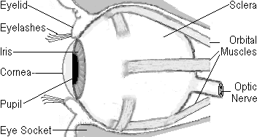

Cut & put 3 eyes on a sheet for students to paste into their notebooks.

